E-R DIAGRAM

ER diagrams are related to data structure diagrams (DSDs), which focus on the relationships of elements within entities instead of relationships between entities themselves. ER diagrams also are often used in conjunction with data flow diagrams (DFDs), which map out the flow of information for processes or systems.

**Data dictionary**

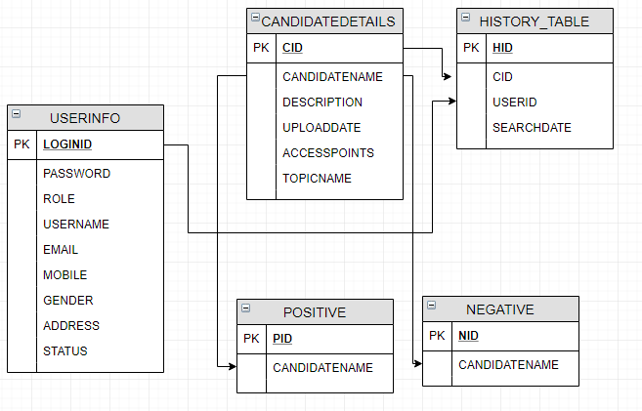

**USERINFO:**

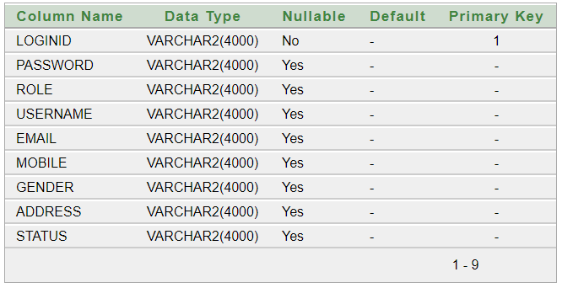

**CANDIDATEDETAILS:**

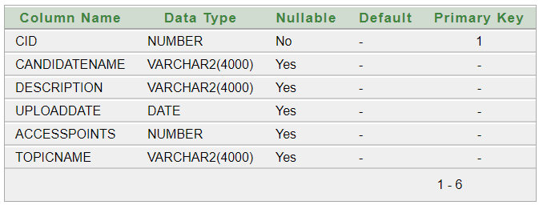

**HISTORY_TABLE:**

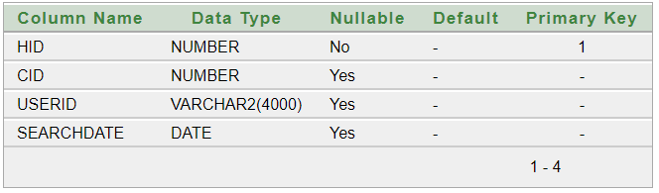

**POSITIVE:** 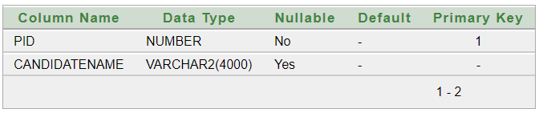

**NEGATIVE:**

